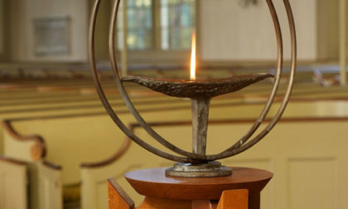
First Unitarian Church of Providence
Prudential Committee Agenda
June 10, 2020

6:45 Check-in
Opening Words (Michael Cappelli)
Call to Order - Chalice Lighting & Covenant Reading
Meditation

7:00 Consent Agenda: May Minutes

Reports: Church Administrator/DRE/Minister/Treasurer Reports: Nancy, Cathy, Liz, Roberta

Ministries Reports/ Personnel, Strategic Planning Reports: Edie, Sam, Greg, David S., Tiffany, Caroline

Discussion:
- Bridging Team
- First U’s Race Work
- Ewert Report on Stewardship: Action Plan for Implementation of Findings
- PruComm Reflection:
  - What did we accomplish?
  - What did we do great as a group in process and outcome?
  - What would we like to do better/differently?

Executive Committee:
- Sabbatical Policy
- Staff Performance Evaluations
- Plan for Summer Services
- Annual Volunteer Recognition Awards

Next Year (Michael)

New Business:

8:50 Review Action Items

Next Meeting/Assignments
- Next Meeting: TBA

Closing Words (Michael Cappelli)
Extinguish Chalice

9:00 Adjourn

With deep joy and a profound sense of responsibility, we gather to do the work of this church.

