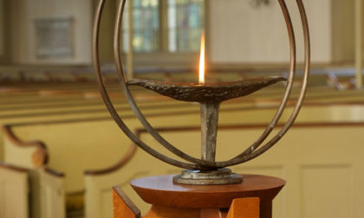
First Unitarian Church of Providence
Prudential Committee Agenda
January 15, 2020

6:45 Check-in
Opening Words (Greg)
Call to Order - Chalice Lighting & Covenant Reading
Meditation

7:00 Consent Agenda: December Minutes

Discussion Items:
- Sanctuary Steering Committee visit
- Leadership Retreat debrief/follow-up (All)
- Special project requests and budget requests (Roberta and David)
- Congregational staff assessment review for FY2021 budget
- May 15th Musicale proceeds
- GA Information

Reports: Church Administrator/DRE/Minister/Treasurer Reports: Nancy, Cathy, Liz, Roberta

Ministries Reports/ Personnel, Strategic Planning Reports: Edie, Sam, Greg, David S.

Executive Committee:
- Intern being sought to Look into First U, the Slave Trade & Abolition Movement
- Stewardship For Us Reminder Feb 21 - Feb 23 Congregational Giving Assessment. All PruComm members should plan to attend
- Kevin Carson Ordination (Liz)
- Sabbatical policy task force update (Michael and Greg)
- Coffee Hour (Roberta)
- Church overnight guest policy (Michael)

New Business

8:50 Review Action Items

Next Meeting/Assignments
- Next Meeting: February 12
- Opening/Closing Words:

Closing Words (Greg)
Extinguish Chalice

9:00 Adjourn

With deep joy and a profound sense of responsibility, we gather to do the work of this church.

